VIT Old Book House System

Software Design Description

Version 1.0 ● 14-March-2018

## MEMBERS:-

## DEBAYAN BHATTACHARYA 16BCI0199

## MAYANK MATHUR 16BCE0568

## OM ASHISH MISHRA 16BCE0789

## PROFESSOR:-

## SENTHILNATHAN P

Contents

Section 1. Overview 1

1.1 Purpose 1

1.2 Scope 1

Section 2. System Architecture 2

Section 3. Class Diagram 3

Section 4. Sequence Diagrams and Descriptions 4

4.1 Sequence Diagram for Authentication Module 4

4.2 Sequence Diagram for Buyer Module 5

4.3 Sequence Daigram for Seller Module ……………………………………………..6

4.4 Sequence Diagram for Payment Module…………………………………………7

Section 5. Activity Diagram 8

5.1 Activity Diagram for Login/SignUp Module 8

5.2 Activity Diagram for Buyer/Seller and Payment Module 8

5.3 Activity Diagram For the Whole System ………………………………………….9

Section 6. State Chart Diagram  10

6.1 State Chart Diagram to depict state transitions of Login/SignUp 10

6.2 State Chart Diagram to depict state transitions of Buyer/Seller and

Payment……………………………………………………………… .. 10

6.3 State Chart Diagram to depict state transitions of Whole Diagram.11

Section 7. Data Design 12

7.1 ER Diagram 12

7.2 Table layout 12

Section 8. Data Flow Diagrams 13

8.1 Level 0 DFD 13

8.2 Level 1 DFD 13

8.3 Level 2 DFD 14

Section 9. Detailed Module Description 14

9.1 VIT Old Book House 15

Section 10. User Interface Design 17

10.1 User Interface Screen for User Login and SignUp 17

10.2 User Interface Screen for Buyer/Seller 18

# Section 1. Overview

## 1.1 Purpose

The project is based on the book selling-buying purpose. The design is made on java user interface. We have used the software Netbeans 8.2.0 for the project. The backend creation is down on SQL. The project is an interface between the seller and buyer where the user can choose to a role at any time of it’s choose. The seller gives the book details and the buyer searches for the book and offers a bargain price. If the book’s bargain price is accepted by the seller then the buyer can proceed to buy the book at the bargain value. Thus payment takes place and the book is bought

## 1.2 Scope

*The software used is a very simple and user friendly software and helps us to make the detailised project on it. Netbeans is useful for the making a user interface software that will in easy communication facilities. The Buyer and Seller will exchange messages in the project through this software.*

# 

# Section 2. System Architecture

Apache Web Server 2.2

# imagesraid1

**Authentication as a User**

**Authentication as Buyer or Seller**

**Buyer and Book Buying**

**And Bargain price**

**Payment of the Book by the buyer and acceptance by seller**

**Seller and Book Selling**

**And Quotation price**

RAID LEVEL 1

Netabens

# imagesSection 3. Class Diagram

PC

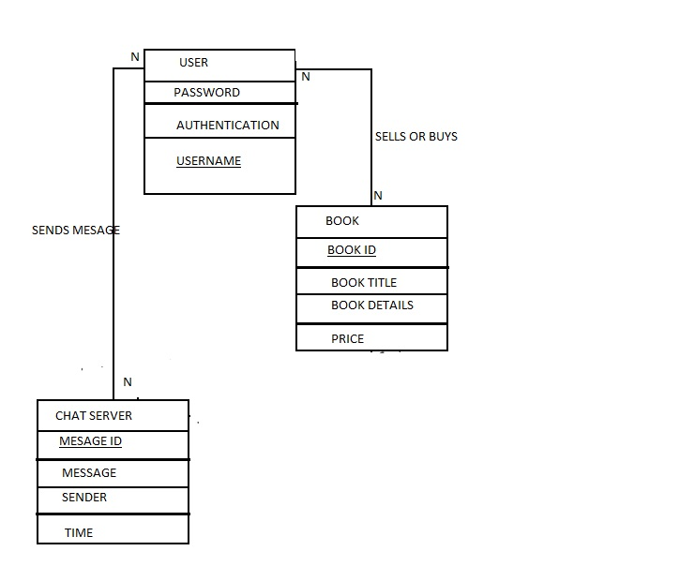

# Section 4. Sequence Diagrams and Descriptions

## 4.1 Sequence Diagram for Authentication

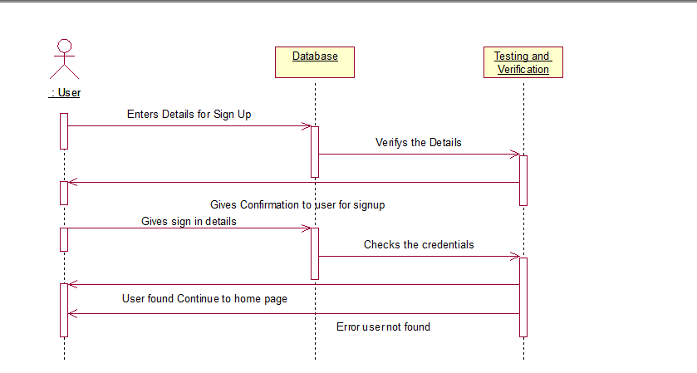

The user first enters the details of his/her into the SIGN UP page and after submission he/she is able to do test and confirm to user for sign up details filled. Then the user logins by giving username and password then the details are checked. The user has two pathways after that: 1) If the user details don’t match it gives an error and 2) if user details are found it displays the Home Page.

Corresponding Collaboration Diagram

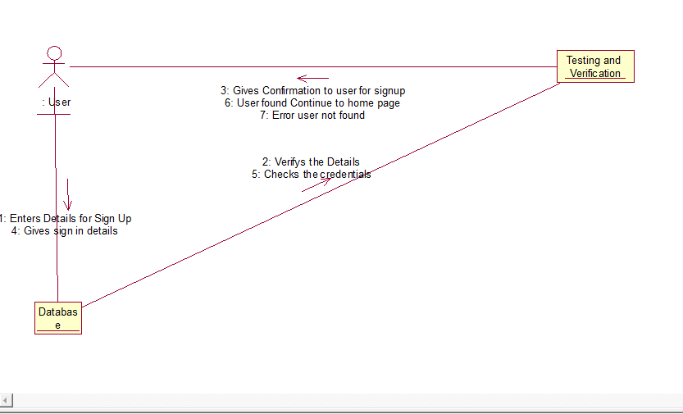

## 4.2 Sequence Diagram for Buyer Module

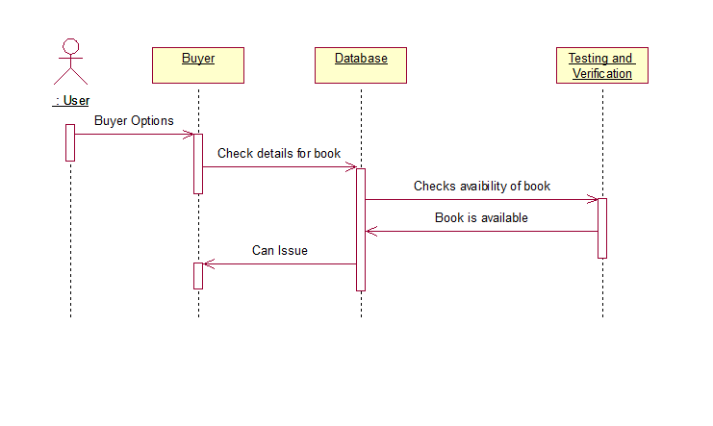

The user after login, if he/she chooses to be as a buyer then he/she can select books that he/she wants from the database. If the book is available then we can issue the books if it is present the database. Then the buyer can buy the book.

Corresponding Collaboration Diagram

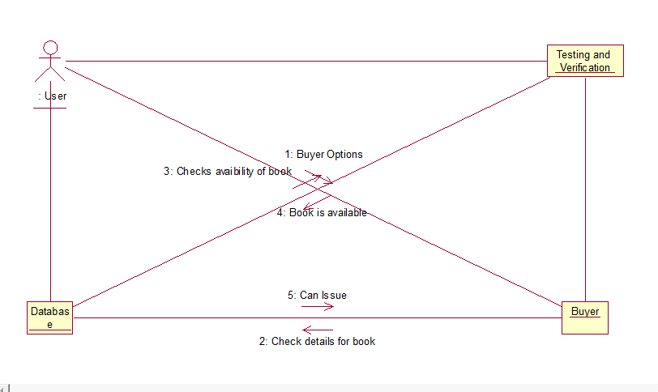

## 4.3 Sequence Diagram for Seller Module

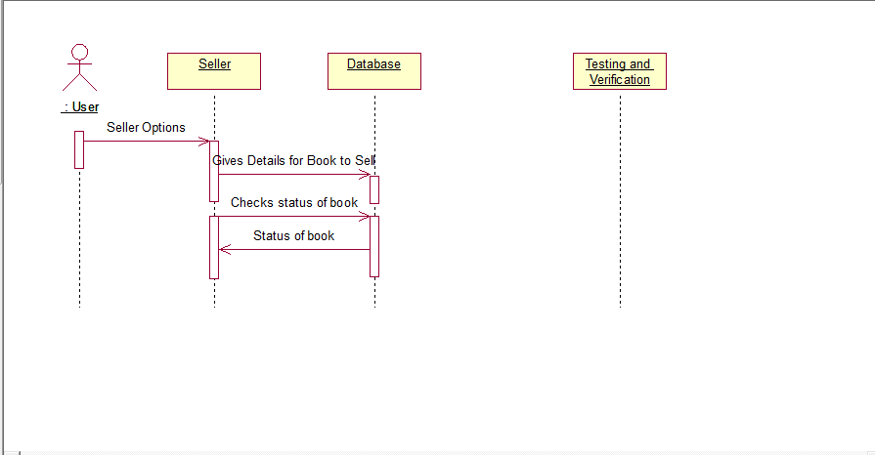

The user as Seller can sell the books through giving the details about the books like name, author, quotation price, edition, type of the book and other details about the book. The Seller is also entitled to check the whether someone has selected to buy the book at the entitled price or at a bargain value is given or not. Then the seller can decide to sell the book at the coated price or not. This is what checking the status is meant here.

Corresponding Collaboration Diagram

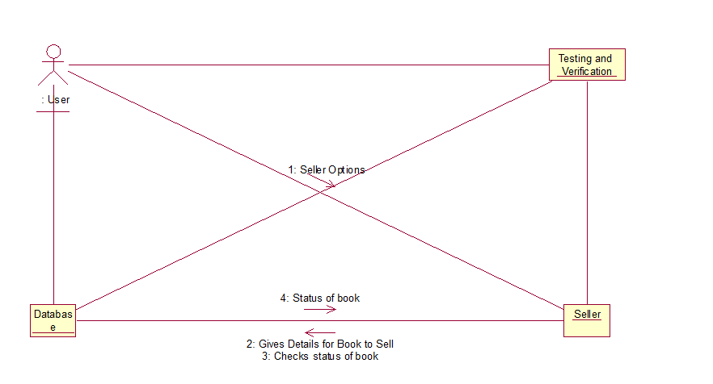

## 4.4 Sequence Diagram for Payment Module

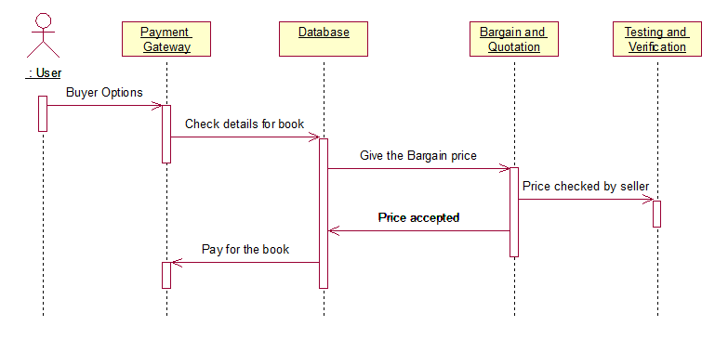

The Buyer after selecting the book goes for buying the book. He checks the details of the selected book and if he/she is not satisfied to pay at the Seller’s amount. The Buyer gives the Bargain price. If it is accepted by the Seller then it is allowed to the buyer to buy it from the price accepted price. Otherwise he has to buy it at price originally given by Seller.

Corresponding Collaboration Diagram

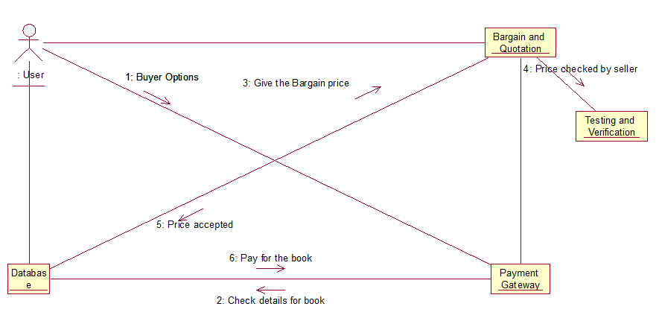

# Section 5. Activity Diagram

## 5.1 Activity Diagram for Login/SignUp Module

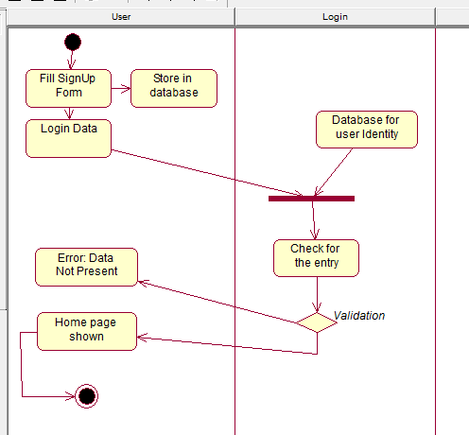

## 5.2 Activity Diagram for Seller/Buyer and Payment Module

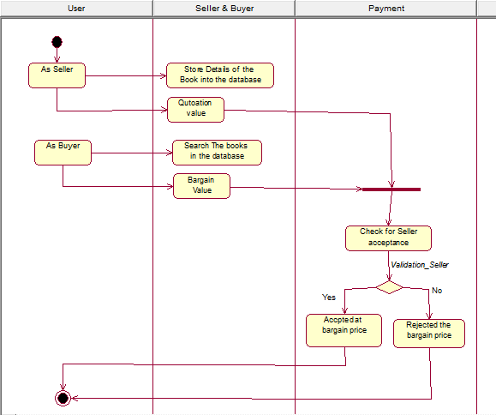

**Activity Diagram as a Whole:**

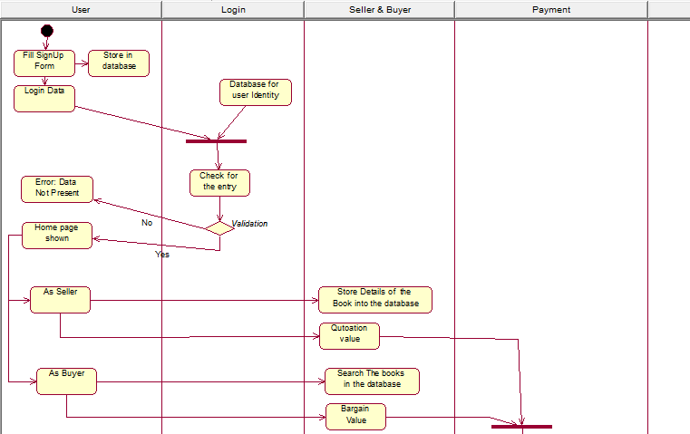

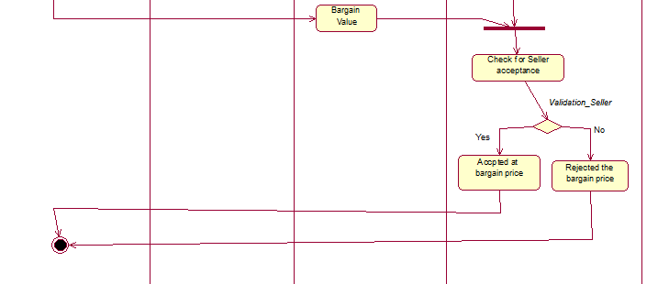

# Section 6. State Chart Diagram

## 6.1 State Chart Diagram to depict state transitions of the General Authentication

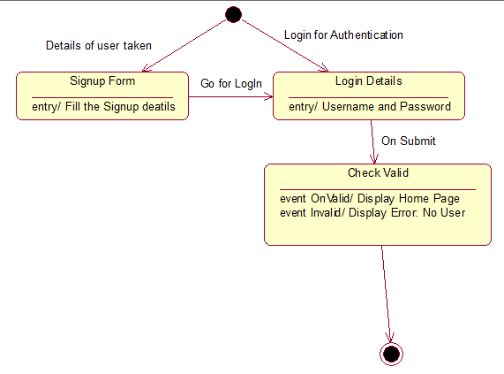

## 6.2 State Chart Diagram to depict state transitions of the Seller/Buyer and Payment

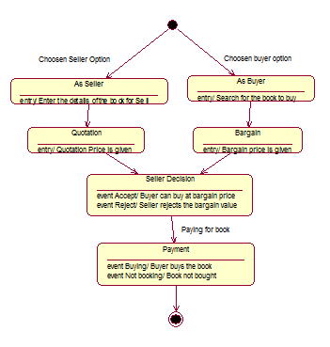

## State Chart Diagram to depict state transitions as a Whole

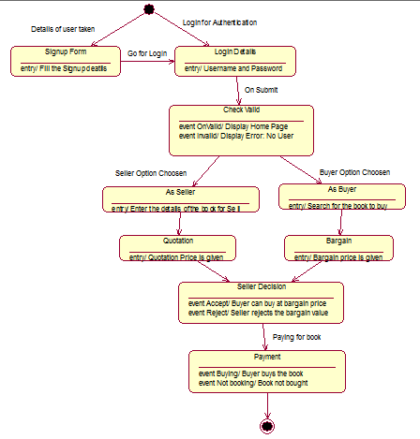

## 

# Section 7. Data Design

## 7.1 ER Diagram

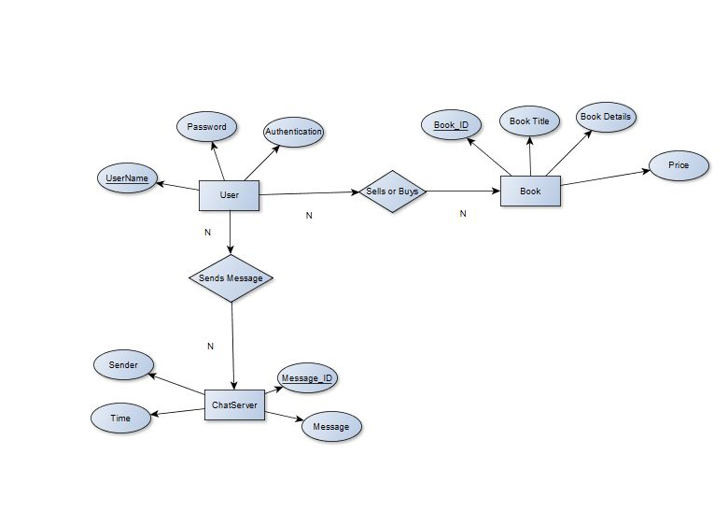

## 7.2 Table layout

**7.2.1. Data Table Layout**

|  |  |
| --- | --- |
| **Attribute** | **Type** |
| Username | Varchar ,Primary key |
| Password | Varchar |
| Authentication | Number |
| BookId | Number,Primary key |
| BookTitle | Varchar |
| BookDetails | Varchar |
| Price | Number |
| MessageID | Number,Primary Key |
| Time | Date |
| Message | Varchar |
| Sender | Varchar |

# Section 8. Data Flow Diagrams

DFD LEVEL 0-

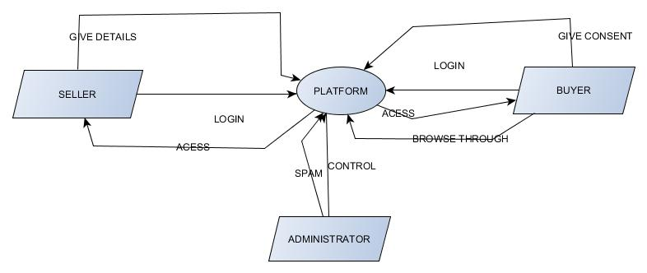

DFD LEVEL 1-

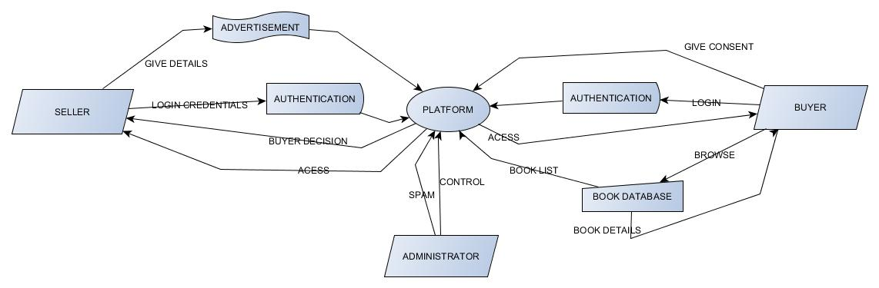

DFD LEVEL 2-

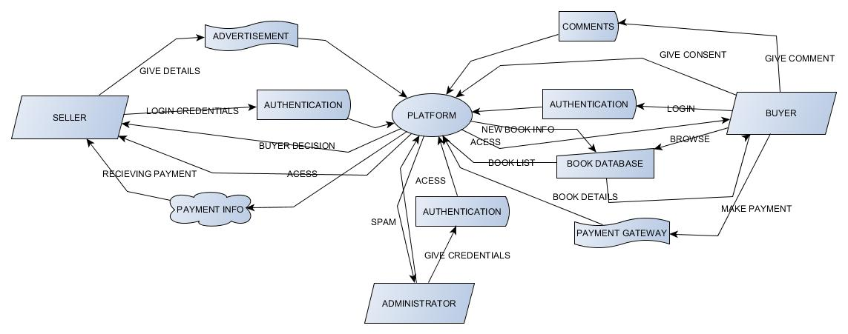

# Section 9. Detailed Module Description

## 9.1 VIT Old BOOK House

9.1.1. Module Description

Authentication module supports the following functions

* Add_details_of_user
* Validate_Sign_Up
* LogIn_detials
* Display_of_Home_Page

Buyer/Seller Option module supports the following functions

* Choose_Buyer_Option
* Choose_Seller_Option

Book Details by Seller Module supports the following functions

* Give_Details( Like book name, author, type)
* Quotation_Price

Book Details by Buyer Module supports the following functions

* Book_Selection
* Bargain_Price(If Any)

Book Details by Payment Module supports the following functions

* Check_the_chat_details
* Payment_Mode
* Payment_Verification

9.1.2. Function Description

9.1.2.1. Function Name – Give_Book_Details, User_Details, Search_Book_Details

9.1.2.2- Input Parameters – Character - Book name, type, author, edition ; User_ID

9.1.2.3- Output Parameters – Quotation_Price and Bargain_Price

9.1.2.4. Called by Functions – Chat with Sender and Receiver

9.1.2.5. Calling Functions – Validate_Login, Validate_Book_Deatils, Update_Database

9.1.2.6 Process

GET input data

CALL Validate_Login (User_ID)

IF valid returned

CALL Update_Database

IF UPDATE successful

DISPLAY Buyer and Seller Successfully

IF SELLER option

Give_Book_Details

ELSE IF BUYER option

Search_Book_Details

ELSE IF PAYMENT option

IF Bargain_Price is accepted THEN

Buy_At_Bargain_Value

ELSE

Buy_At_Quotation_Value

PAYMENT_MODE Successfully done

Validate_Book_Deatils, Update_Database

ELSE

EXIT_FROM_APP

END

# 

# Section 10. User Interface Design

## 10.1 User Interface Screen for User Login

LOGIN PAGE:

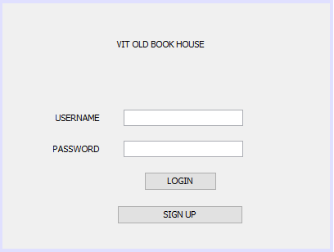

SIGN UP PAGE:

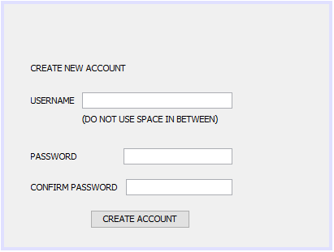

## 10.2 User Interface for Buyer and Seller Module



 